Table 1. Important Functional Groups in Biology
Functional Group | Structure | Properties | General Features
Hydroxyl | 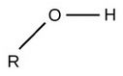 | Polar  Hydrophilic | Characterized by presence of H and O  Simple structure
Sulfhydryl | 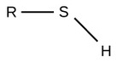 | Polar | Characterized by presence of S  Simple branched structure
Methyl | 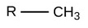 | Nonpolar | Characterized by presence of H and C  Simple structure
Carbonyl | 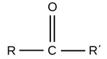 | Polar | Characterized by central C and O  Bound to 2 organic side groups  Double bond to oxygen increases the polarity
Carboxyl | 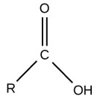 | Charged, ionized to release H⁺. Since carboxyl groups can release H⁺ ions into a solution, they are considered acidic. | Characterized by central C bound to O and OH  Acidic
Amino | 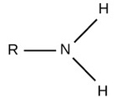 | Charged, accepts H⁺ to form NH₃⁺. Since amino groups can remove H⁺ from solution, they are considered basic. | Characterized by presence of N  Branched structure
Phosphate | 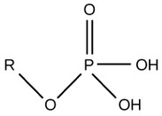 | Charged, ionizes to release H⁺. Since phosphate groups can release H⁺ ions into solution, they are considered acidic.  Acidic | Characterized by presence of P  Complex structure

